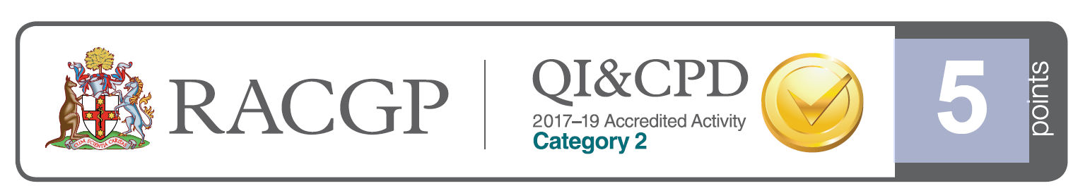
Dear Doctor,
You are cordially invited to our upcoming education evening at:
Mantra Chatswood,
The North Room,
10 Brown Street, Chatswood NSW
6.00pm | Dinner
6.30pm | Dr Katherine Masselos– Systemic Medications with Ocular Side Effects
 | Question Time – 10 minutes
7.10pm | Dr Geoff Wilcsek – Getting comfortable with periorbital skin lesion
 | Question Time – 10 minutes
7.50pm | Dessert & Coffee
8.00pm | Dr John Downie – Floaters and all that
 | Question Time – 10 minutes
8.40pm | Finish
RSVP: Thursday 8th November
Yes, I am able to attend. Dietary requirements……………………………………………….
No, I am unable to attend
Phone: 9411 5000 Fax: 94131839 Email: office@chatswoodeye.com
Parking is available onsite at Mantra Chatswood ($15)

Alternatively, it is a 5 minute walk from Chatswood Westfield parking
Sponsored by:

