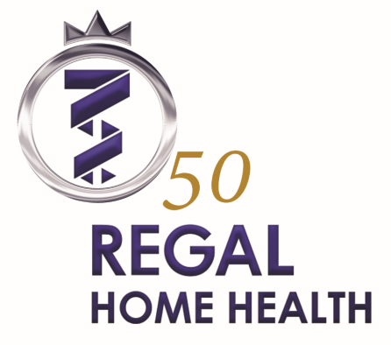
Level 19, St Martins Tower
31 Market Street
SYDNEY NSW 2000
Phone (02) 9264 4555
Facsimile (02) 9264 4556
Email regal@regalhealth.com.au

- Market leader in Community Health
- A company that has looked to the future for over 50 years
- Great team, great Sydney CBD location

Regal is synonymous with clinical excellence in the home health market. With an excellent brand, Regal Home Health is increasing the scope of its services to cover the requirements of its clients in DVA, not for profit, NDIS, ICARE and home care package markets. The increase in services will be launched with a new visual identity, new web site and new marketing collateral.
To cater for this growth we are looking for a new team member to actively case manage patients and clients through developing new or modifying existing care plans. The successful candidate will be required to work with multi-disciplinary teams, liaise with General Practitioners and develop recommendations, reports and proposals as required. You will be coordinating a client base and utilising a team of Nurses to ensure your clients’ clinical and care needs are assessed and managed whilst delivering high quality service to all stakeholders. As part of the care coordination team you will be reporting through to the Chief Operations Manager and supported by the Director of Clinical Excellence and Manager of Corporate Governance.
To become part of our team the successful candidate will have:
- Current AHPRA registration or strong background in healthcare
- Experience with all or some of the following clients- DVA, ICARE, NDIS, Home Care Package and private referrals
- Excellent customer service, administrative, computer and phone skills
- Ability to produce care plans and assessment documentation
- Skills in care-coordination within the Community environment
At Regal we believe in “Humanity for Humanity”. As such, the ability to value our clients, patients and team members and demonstrate the desire to make a difference will count significantly in our selection process.
Attractive packages available.
To become part of our team please forward your details to workhappy@regalhealth.com.au

