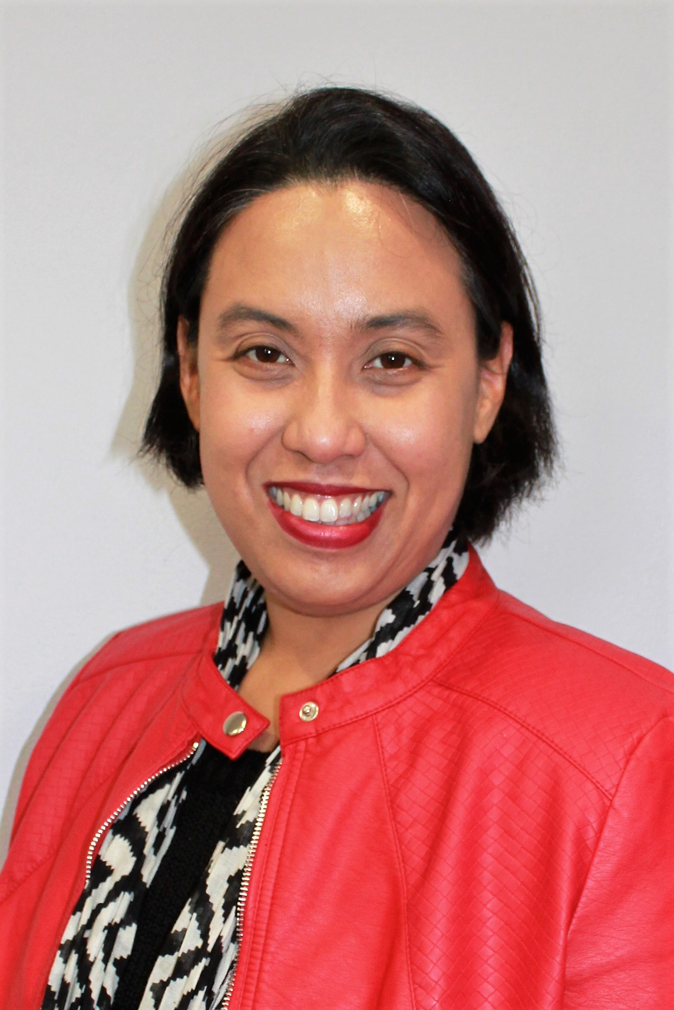

Founder and Director
Ms Valerie Ling
Clinical Psychologist

With more than 20 years of experience as a Psychologist, Valerie Ling has drawn on her experience in organisational psychology, clinical psychology, forensic psychology, pastoral care and business leadership to create a dynamic and sought-after psychology practice.

Valerie combines her passion for working with clients regarding burnout prevention, carer resiliency, trauma and complex anxiety disorders with her dedication to positively impacting the lives of others. She is approved by the Psychology Board of Australia to supervise psychologists in clinical psychology and she maintains the principal supervision over Psychologists in the practice.

Valerie is the author of two books published for pastoral use and enjoys writing on topics that reduce mental health stigma and promote ways in which individuals can seek early intervention. She has also contributed to writing material for training programmes in chaplaincy and mental health literacy.

As a professional speaker, Valerie is often in high demand for her engaging and down-to-earth approach to covering complex topics. She speaks about burnout and resilience and tailors her talks to suit her audience’s needs. From teachers, medical and dental professionals to clergy, chaplains, cross-cultural workers and educators, Valerie has a way of speaking into the lives of everyone she meets.

