www.marjenes.com.au

Sydney September 2017 Day Course (9-5) on Infection Prevention & Control to all General Practice staff

Tues 19th Epping venue tba or Wed 20thTank Stream Hotel CBD Pitt St. or Thurs 21st Parramatta central venue tba

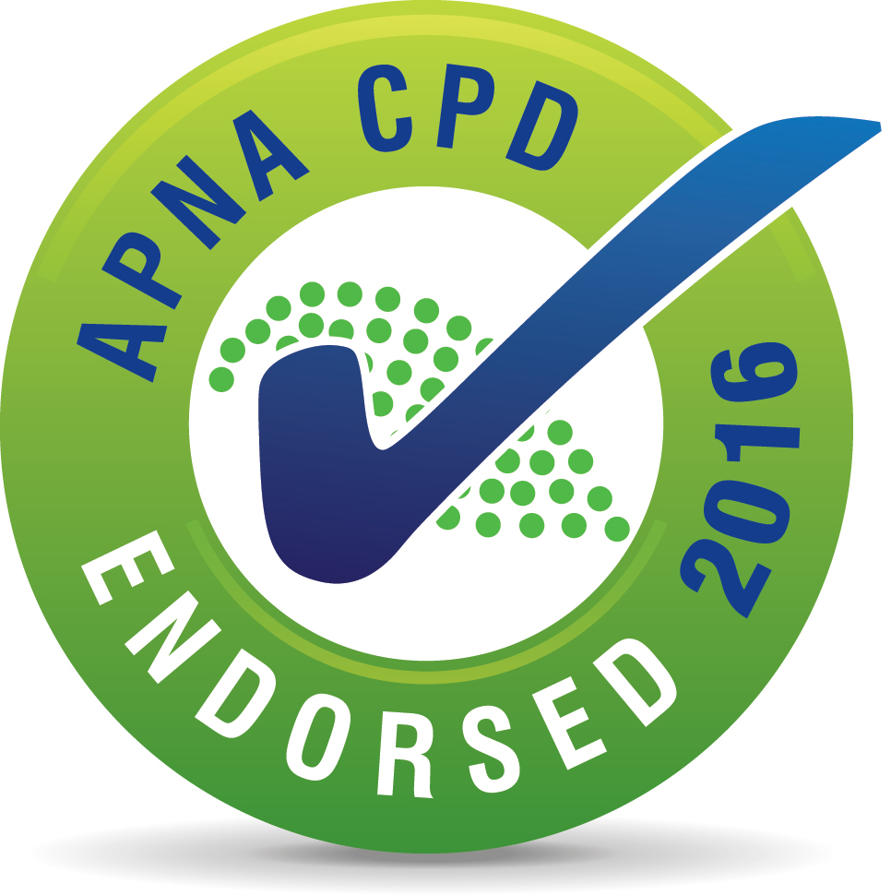

“This activity has been endorsed by APNA according to approved quality standards criteria.”

This day session has been allocated 8 CPD hrs and assists achieve reaccreditation requirements in Infection Control
Features
- Small group of 10 - 14 to enhance competency checking experience. Suits nurses and receptionists.
- All materials supplied , a complimentary copy of my 2017 prac guide and cleaning policy template included
- Tea/Coffee on arrival, morning tea, single course lunch with wine, special dietary requirements catered for
- No deposit or prepay - invoice sent after course
- fee per person is $330 ($220 if non working or attending with a full fee paying colleague ) Schedule
- Session starts with 15 minutes registration / coffee. Those not sterilising instruments may leave an hour early
Topics
- Triage & suspect flu/gastro/measles, Precautions, Immunisation, Clinical Waste, Sharps Injury (90 mins)
- Competency checking for Hand hygiene, use of PPE for both flu and spills, cleaning, body fluid spills (2 hours)
- Aseptic procedure principles & best practice for hand hygiene, glove changes and surface cleaning (30 minutes)
- Multiresistant Organisms, MRSA, cleaning/disinfection post patient (30 minutes)
- Instrument processing (2 hours in total or 1 hr if you do not performing instrument sterilisation at work)
---------------------------------------------------------------------------------------------------------------------------------

Complete details below for each attendee. Email marjenes@optusnet.com.au or fax 03 9439 2436

1. Which date and location are you attending? (see above three dates and locations) …..

2. Your name as you want it printed on your certificate………..

3. Your mobile contact details for the day…….

4. Best accessible email address for notes and communication in the time leading up to the session

5. Are you leaving at 4pm? YES / NO.

6. Do you have any dietary requirements - state………….

7. Indicate the name and email address of the person receiving the electronic invoice after the course

I will confirm your booking as soon as I receive this completed form. enquiries

Margaret Jennings (Mobile 0404 088 754),
Microbiologist and Infection Prevention & Control Educator/Consultant to Office Based Practice

