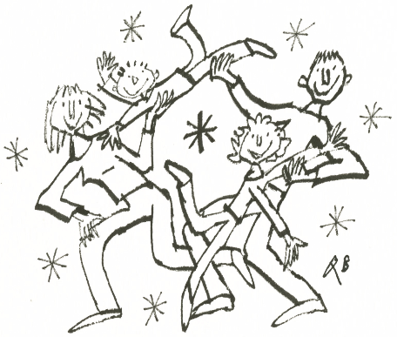
Hornsby Healthy Kids
Hornsby General Practice Unit
3-7 Derby Road, Hornsby 2077
© Quentin Blake 2014
Hornsby Ku-ring-gai Hospital
Department of Paediatrics
Phone 9477 9146 Fax 9477 9824

GP Referral Form Fax completed form to 9477 9824
A multidisciplinary weight management service for overweight or obese children <12 years old and their families staffed by:
Paediatricians – Dr Anna Gill / Dr Kate Webster; GP – Dr Jennifer Kendrick ; Exercise therapist –Tom Carruthers; Dieticians – Kerryn Chisolm and Caroline Hill; Clinical Psychologist – Beatrijs Dewulf;; Registered Nurse Nicole Page; GP Registrar.

PATIENT DETAILS
Surname: | First Name:
Date of Birth: | Sex: Male Female

PARENT / CARER CONTACT DETAILS
Name:
Home phone: | Mobile phone:
Language spoken at home:
Interpreter required: Yes No | If yes, specify language:

CLINICAL DETAILS
Weight: |  | Height:
BMI: | BMI centile:
(see reverse of this page for calculation and tables)
Go4Fun completion date if applicable:
Investigations if already performed:
Not needed routinely, please attach results if applicable.
(Consider fasting BSL, Insulin, TG, Cholesterol +/- Vit D, iron studies, LFTs.)
Other significant medical or social history:

PATIENT AGREEMENT

I, …………………….…………………………. (parent/guardian name) have discussed the referral to Hornsby Healthy Kids with our doctor and consent to participate. I understand that participation in the clinic requires regular attendance and monitoring of progress and that measurements and progress will be recorded and used for ongoing evaluation of the clinic program.

…………………….…………………………. (parent / guardian signature)

REFERRING DOCTOR DETAILS
Name:
Provider number:
Address:
Phone: | Fax:
Signature | Date:

BMI centile charts taken from CDC Growth charts Overweight is defined as 85th to 95th centile for age. Obese is defined as over the 95th centile for age.
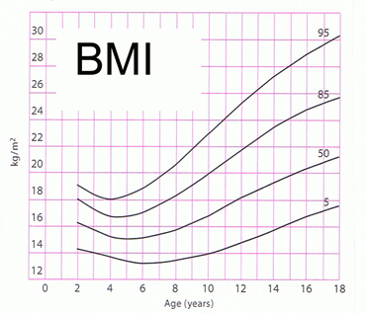
Girls
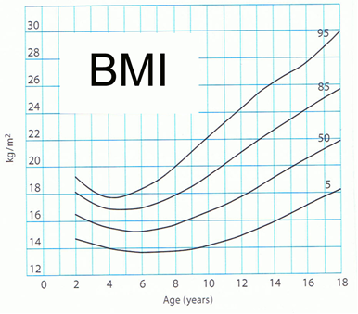
Boys

Body Mass Index (BMI) = weight in kg ÷ (height in metres)²

