www.marjenes.com.au

2017 Sydney Private Day Course in Infection Prevention & Control to all General Practice staff

September Tues 19th Epping (Epping Club 45-47 Rawson St, Epping, 200 metres from Epping station, limited parking)
or
September Wed 20th City ( Primus Hotel, 339 Pitt Street, nearest station is Town Hall)
or
September Thurs 21st Parramatta (Parkroyal, 30 Phillip Street Parramatta, 10 mins walk from Parramatta station)

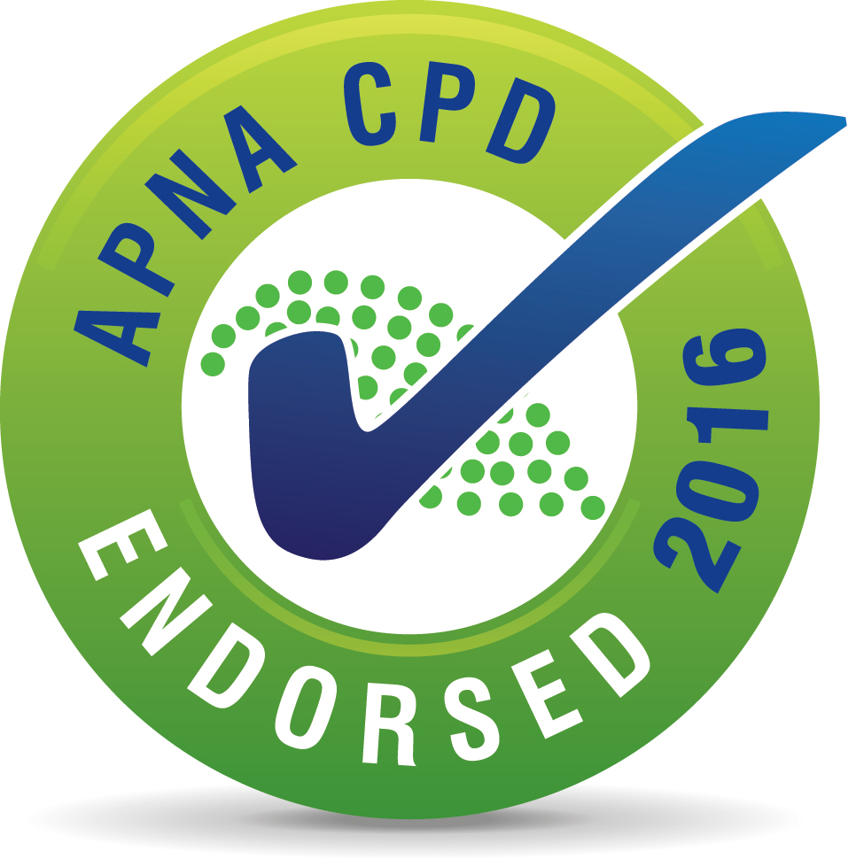

“This activity has been endorsed by APNA according to approved quality standards criteria.”

This day session has been allocated 8 CPD hrs and assists achieve reaccreditation requirements in Infection Control
Features
- Small group of 10 - 14 to enhance competency checking experience. Suits nurses and receptionists.
- All materials supplied , a complimentary copy of my 2017 prac guide and cleaning policy template included
- Tea/Coffee on arrival, morning tea, single course lunch with wine, special dietary requirements catered for
- fee per person is $330 ($220 if non working or attending with full fee colleague ) - no prepay, invoice sent after
Topics
- Triage & suspect flu/gastro/measles, Precautions, Immunisation, Clinical Waste, Sharps Injury (90 mins)
- Competency checking for Hand hygiene, use of PPE for both flu and spills, cleaning, body fluid spills (2 hours)
- Aseptic procedure principles & best practice for hand hygiene, glove changes and surface cleaning (30 minutes)
- Multiresistant Organisms, MRSA, cleaning/disinfection post patient (30 minutes)
- Instrument processing (2 hours in total or you may leave at 4pm if you do not process instruments at work)
---------------------------------------------------------------------------------------------------------------------------------

Complete details below for each attendee. Email marjenes@optusnet.com.au or fax 03 9439 2436

1. Which date and location are you attending? (see above three dates and locations) …..

2. Your name as you want it printed on your certificate………..

3. Your mobile contact details for the day…….

4. Best accessible email address for notes and communication in the time leading up to the session

5. Are you leaving at 4pm? YES / NO.

6. Do you have any dietary requirements - state………….

7. Indicate the name and email address of the person receiving the electronic invoice after the course

I will confirm your booking as soon as I receive this completed form. enquiries
Margaret Jennings (Mob 0404 088 754), Microbiologist/Infection Prev & Control Educator/Consultant to Office Based Practice

